Data Analytics Capstone
Interim Report
The Economic Efficacy of State-Level Renewable Energy Subsidies:
A Multi-Factor Predictive Analysis
Alok Srivastava
Walsh College
QM640: Data Analytics Capstone
Rishabh Pandey
Fall 2025 Term
05 May 2026

GitHub Repository Link
https://github.com/aloksrivastava1/QM640-Energy-Analytics

1. Introduction
Background and Context
Over the past decade, the United States has undergone a fundamental transformation in its electrical grid infrastructure, driven by an urgent mandate to decarbonize energy production. State governments and regional utility commissions have allocated billions of dollars in taxpayer and ratepayer funds toward financial subsidies to accelerate the deployment of renewable energy, particularly decentralized residential and commercial solar photovoltaic (PV) capacity. The foundational macroeconomic assumption driving these utility-funded programs is that direct consumer financial incentives such as installation rebates, net-metering premiums, and localized tax credits serve as the primary catalyst for clean energy transitions across diverse geographic regions.
However, the global energy landscape has shifted drastically since these localized incentive programs were originally designed. Free-market technology cost reductions, governed by Swanson's Law (which dictates that the price of solar PV modules drops by approximately 20% for every doubling of cumulative shipped volume globally), have made solar hardware inherently competitive without the need for continuous artificial market stimulation. Concurrently, broader macroeconomic forces such as massive fluctuations in the Federal Reserve's bank loan interest rates have significantly altered the cost-of-capital required for homeowners and businesses to finance these highly capital-intensive installations.
Furthermore, the aggressive, historically subsidized deployment of solar capacity has introduced severe physical constraints to state electrical grids. The most notable constraint is the 'Duck Curve' phenomenon, wherein mid-day solar over-generation threatens grid stability as the sun sets and consumer demand spikes. Consequently, key stakeholders ranging from state utility commission directors and regional grid planners to clean-tech investors are increasingly debating whether historical capital allocations should pivot away from direct solar panel subsidies and toward foundational grid-readiness infrastructure, specifically utility-scale and PV-paired battery storage systems.
Problem Statement
Despite the rapid evolution and maturity of the renewable energy sector, existing state policies continue to heavily rely on capacity-based financial subsidies without empirically measuring their true causal efficacy against natural macroeconomic growth, nor their overall economic drag on Gross Domestic Product (GDP). This creates a critical problem of capital inefficiency: billions of dollars may be misallocated toward incentivizing a technology (solar panels) that is already being driven by free-market forces and social contagion, while severely underfunding the critical grid infrastructure (battery storage) required to safely utilize that energy. The core gap addressed by this research is the lack of a multi-dimensional, machine-learning-validated econometric model capable of isolating the true predictive weight of state financial subsidies against non-linear macroeconomic constraints.
Purpose of the Study
The primary purpose of this study is to utilize an exhaustive 11-year longitudinal panel dataset (spanning 2014–2024) encompassing all 51 primary U.S. geographical entities to mathematically evaluate and explain the true drivers of solar PV adoption. By deploying a dual-modality approach utilizing a SHAP-explained Random Forest Machine Learning pipeline to predict adoption patterns, combined with a Fixed Effects Panel Ordinary Least Squares (OLS) regression for causal inference this study aims to strictly quantify the exact causal impact of state subsidies versus non-financial macroeconomic predictors. The ultimate goal is to generate a statistically defensible, data-driven policy roadmap to guide utility commissioners in the strategic reallocation of state-level green energy funds.
Interim Project Status (Progress Snapshot)
- Completed: Master dataset collection and harmonization (N=561 longitudinal observations across 12 features from EIA, BEA, FRED, and NREL), initial data cleaning (including domain-specific null imputation for early-year battery capacities), and Exploratory Data Analysis (EDA) covering target variable outlier identification and macroeconomic correlation mapping.
- In progress: Feature engineering (logarithmic transformation of extreme scale outliers, dataset bias mitigation, categorical dummy encoding), baseline predictive model training (Ridge Regression, SVR), and preliminary dual-modality pipeline execution (Random Forest vs. Panel OLS).
- Pending: Advanced hyperparameter tuning via cross-validation, final validation of the SHAP sub-group analysis (evaluating the market maturity shift between California and the developing U.S.), and formulation of the categorical, phase-based policy recommendations for end-users.

Scope and objectives
The scope of this analytical project encompasses a full 11-year timeframe spanning from 2014 to 2024. The data encompasses all 51 primary geographical entities within the United States (U.S.), generating a master national dataset of N = 561 longitudinal panel observations. The study aggregates and strictly documents 12 distinct predictive features, combining disparate data silos from highly regulated federal and academic entities to ensure maximum data integrity. The measurable objectives of this study are three-fold:
- To mathematically isolate the causal macroeconomic effect of state subsidies on both solar capacity and state Gross Domestic Product (GDP), factoring out unobserved state-level wealth biases.
- To rank 12 macroeconomic factors by their true predictive weight using a cross-validated Machine Learning (ML) algorithm to understand complex, non-linear market drivers.
- To determine, via sub-group analysis, how predictive market dynamics and grid constraints fundamentally shift when a state transitions from a developing solar market to an absolutely mature, high-penetration market.

Research Problems
To systematically achieve the aforementioned objectives, this capstone addresses four explicit, testable research problems:
Synthesis of Research Questions: To achieve the primary objective of this capstone generating a data-driven, actionable policy roadmap for utility commissioners the four research questions were designed not as independent queries, but as a sequential, highly interdependent methodological pipeline. They function together to form a singular, cohesive narrative:
Establishing the Baseline (RQ1): The analysis begins by deploying a Machine Learning framework (Random Forest) to identify which macroeconomic factors strongly correlate with solar adoption. This establishes our predictive baseline (identifying financial subsidies as the dominant correlative predictor).
Testing for Causal Truth (RQ2): Because correlation does not equal causation, RQ2 acts as a direct methodological counterweight to RQ1. It deploys an Econometric model (Fixed Effects Panel OLS) to mathematically "freeze" state wealth and geographic size, testing whether the subsidies identified in RQ1 actually cause solar growth, or if they are merely a spurious byproduct of wealthy states.
Measuring the Macro-Cost (RQ3): Building upon the causal findings of RQ2, RQ3 expands the scope to evaluate the overall cost of these policies, testing whether ratepayer-funded subsidies act as a measurable macroeconomic stimulus or an economic drag on a state's overall GDP.
Evaluating Market Maturity (RQ4): Finally, RQ4 synthesizes the previous findings by testing how the rules of adoption established in RQ1 and RQ2 fundamentally shift when a state scales from a developing solar market to an absolute mature market (e.g., encountering the "Duck Curve").
The Unified Outcome: By structuring the analysis so that the machine learning modality identifies the market signals (RQ1), the econometric modality tests those signals for causal truth (RQ2 & RQ3), and the sub-group modality scales them for market maturity (RQ4), the project yields a single, concrete outcome: The Phased Policy Playbook. This playbook provides state regulators with distinct, categorical recommendations tailored to their exact level of market penetration.
- Research Question 1 (RQ1): How do macroeconomic, regulatory, and environmental factors comparatively predict solar capacity adoption across the United States when evaluated through a non-linear machine learning framework?
Hypothesis (H0): Non-financial macro factors <= Direct financial subsidies.
Hypothesis (Ha): Non-financial macro factors > Direct financial subsidies.
- Research Question 2 (RQ2): Do state-level utility financial subsidies have a statistically significant causal impact on the adoption of solar energy capacity?
Hypothesis (H0): State-level utility financial subsidies have no statistically significant causal impact on the adoption of solar energy capacity (p > 0.05).
Hypothesis (Ha): State-level utility financial subsidies have a statistically significant positive causal impact on the adoption of solar energy capacity (p ≤ 0.05).
- Research Question 3 (RQ3): What is the macroeconomic impact of state-level utility subsidies on a state's overall Gross Domestic Product (GDP)?
Hypothesis (H0): State-level utility subsidies have no statistically significant causal impact on a state's overall GDP (p > 0.05).
Hypothesis (Ha): State-level utility subsidies have a statistically significant causal impact (either positive or negative) on a state's overall GDP (p ≤ 0.05).
- Research Question 4 (RQ4): Does the predictive importance of grid-scale battery storage and financial subsidies shift significantly when transitioning from developing solar markets to mature, high-penetration markets (e.g., California)?
Hypothesis (H0): Predictive importance remains constant across market maturity.
Hypothesis (Ha): Predictive dynamics shift fundamentally in mature markets.

2. Literature survey

Literature Review Approach
The literature selection process for this capstone was designed to bridge two distinct academic disciplines: energy economics and advanced data science methodology. Sources were systematically gathered using academic databases including Google Scholar, IEEE Xplore, the National Bureau of Economic Research (NBER), and the National Renewable Energy Laboratory (NREL) publication repository. Search queries utilized combinations of keywords such as "renewable energy economics," "solar PV subsidies," "Duck Curve," "fixed effects panel OLS," "dataset bias," and "predictive machine learning." Inclusion criteria were strictly limited to peer-reviewed journal articles, foundational statistical textbooks, and official federal techno-economic reports. The selected literature is divided into two primary wings: the first wing (Sources 1–5) provides the macroeconomic and physical grid context necessary to formulate Research Questions 2, 3, and 4. The second wing (Sources 6–10) provides the mathematical and data-ethical frameworks required to ensure the methodological integrity of the Machine Learning pipeline (RQ1) and the causal econometric models.

Summary of Key Literature
1. Borenstein, S. (2017). The private and public economics of renewable electricity generation. (1) Purpose: To rationalize the foundational economic logic behind subsidizing renewable energy. (2) Method: Economic theory synthesis and literature review. (3) Findings: Subsidies are intended to correct negative environmental externalities, but direct financial interventions often suffer from severe capital inefficiencies depending on market structures. (4) Relevance: Establishes the baseline economic theory that our causal OLS model (RQ2) is attempting to empirically test.
2. Crago, C. L., & Chernyakhovskiy, I. (2017). Are policy incentives for solar power effective? (1) Purpose: To evaluate the efficacy of early-stage solar policy incentives in the Northeast U.S. (2) Method: Econometric regression analysis. (3) Findings: The study found highly mixed results regarding the true efficacy of financial subsidies when controlling for local demographics. (4) Relevance: Provides direct academic precedent for RQ2 and RQ3, justifying the hypothesis that state-level subsidies may act as spurious correlations rather than true causal drivers.
3. Kavlak, G., McNerney, J., & Trancik, J. E. (2018). Evaluating the causes of cost reduction in photovoltaic modules. (1) Purpose: To quantify the mechanisms driving 'Swanson's Law' (the rapid deflation of solar hardware prices). (2) Method: Quantitative cost-modeling and historical supply chain analysis. (3) Findings: Global manufacturing scale, rather than localized state policy, is the overwhelming driver of cost reductions. (4) Relevance: Justifies the inclusion of 'Year' as a mathematical temporal fixed effect in our models, ensuring natural market deflation is controlled for.
4. Cole, W. J., & Frazier, A. W. (2019). Cost projections for utility-scale battery storage. (1) Purpose: To project the economic necessity of battery storage integration. (2) Method: NREL techno-economic capacity expansion modeling. (3) Findings: The integration of utility-scale batteries is an absolute necessity for grid stability in high-penetration solar markets (the 'Duck Curve'). (4) Relevance: Directly supports RQ4, explicitly justifying the inclusion of Total_Battery_MW as a core predictive feature in the mature market sub-group analysis.
5. Hughes, J. E., & Podolefsky, M. (2015). Getting green with solar subsidies: Evidence from the California Solar Initiative. (1) Purpose: To explicitly evaluate the market dynamics of California's massive solar subsidy experiment. (2) Method: Difference-in-differences econometric modeling. (3) Findings: California’s market exhibits unique adoption curves and scale dynamics that do not mirror the rest of the country. (4) Relevance: Explicitly justifies the methodological decision to isolate California as a unique 'mature market' outlier in the RQ4 SHAP analysis.
6. Button, K. S., et al. (2013). Power failure: why small sample size undermines the reliability of neuroscience. (1) Purpose: To highlight how mathematically underpowered datasets undermine causal inference. (2) Method: Statistical power and sample size analysis. (3) Findings: Low statistical power drastically increases the likelihood of Type II errors (false negatives) and inflates discovered effect sizes. (4) Relevance: Provides the strict mathematical justification for conducting an a-priori Power of Test to validate our N=561 longitudinal dataset.
7. Gebru, T., et al. (2021). Datasheets for Datasets. (1) Purpose: To establish an ethical framework for dataset creation and deployment. (2) Method: Development of a standardized data transparency framework. (3) Findings: Lack of transparency regarding dataset construction leads to systemic algorithmic harm and bias. (4) Relevance: Drives the rigorous documentation and provenance of our federal data silos (EIA, BEA, NREL) in the Data Description and Bias/Data Ethics sections.
8. Torralba, A., & Efros, A. A. (2011). Unbiased Look at Dataset Bias. (1) Purpose: To evaluate how machine learning algorithms exploit dataset-specific artifacts. (2) Method: Cross-dataset generalization experiments. (3) Findings: Models will aggressively "memorize" specific dataset idiosyncrasies rather than learning generalizable, real-world rules. (4) Relevance: Directly informs our Feature Engineering phase, dictating the removal of the categorical "State" identifier from the Random Forest training matrix to prevent algorithm memorization.
9. Chu, X., et al. (2016). Data Cleaning: Problems and Current Approaches. (1) Purpose: To address the complexities of merging disparate data sources. (2) Method: Survey of computational data cleaning techniques. (3) Findings: Resolving conflicting temporal and spatial granularities is the most critical step in preventing downstream algorithmic failure. (4) Relevance: Guides the stringent imputation strategies and temporal aggregation techniques used to merge daily federal interest rates with annual EIA state capacity reports.
10. Redman, T. C. (1998). The Value of Good Data: A Quality Perspective. (1) Purpose: To assess the impact of data quality on strategic analysis. (2) Method: Quality management framework analysis. (3) Findings: "Garbage in, garbage out" (GIGO) fundamentally destroys decision-making models. (4) Relevance: Empirically justifies the extensive EDA phase and the mathematical necessity of applying logarithmic transformations to the highly skewed California target variable.
Table 1
Literature Relevance Matrix
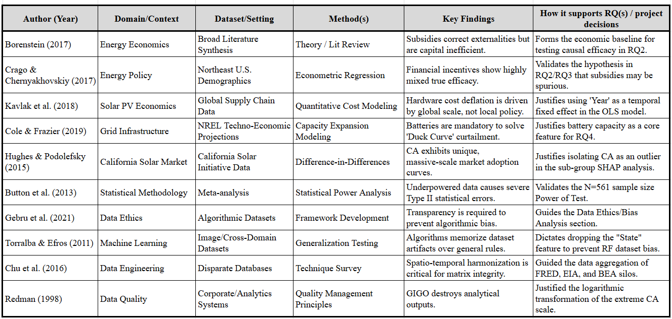

Thematic Synthesis of Literature
The Economic Theory vs. Causal Reality of Subsidies (RQ2 & RQ3) The foundational literature surrounding energy economics reveals a significant gap between theoretical policy intent and actual empirical outcomes. Borenstein (2017) establishes the primary economic justification for solar subsidies correcting environmental externalities but warns of their potential inefficiency. This warning is explicitly empirically validated by Crago & Chernyakhovskiy (2017), whose regression models on early-stage U.S. markets demonstrated highly mixed returns on direct financial incentives. Our capstone directly addresses this thematic tension. By utilizing a Fixed Effects Panel OLS (RQ2 and RQ3), this project attempts to resolve whether the theoretical benefits outlined by Borenstein actually materialize as causal growth, or if they suffer from the inefficiencies warned of by Crago.
Market Maturity and the Grid Constraint Paradigm (RQ4) A secondary theme within the literature focuses on how physical hardware and grid constraints eventually supersede localized financial policy. Kavlak et al. (2018) definitively prove that Swanson’s Law (global manufacturing scale) drives down panel prices far more effectively than state-level rebates. Concurrently, Cole & Frazier (2019) identify the "Duck Curve" as the ultimate bottleneck for mature markets, proving that without grid-scale battery storage, solar over-generation becomes a liability rather than an asset. Hughes & Podolefsky (2015) confirm that the California market operates on a completely different paradigm due to these massive scale dynamics. Together, these papers form the theoretical backbone of RQ4, driving the hypothesis that as a state matures (like California), direct financial subsidies lose predictive importance, replaced by the necessity of battery storage and the macroeconomic reality of global hardware deflation.
Methodological Rigor and Data Integrity (RQ1 & RQ2) The final theme synthesized from the literature ensures the mathematical and ethical viability of the project's dual-modality pipeline. Button et al. (2013) establish the absolute necessity of statistical power, which drove the rigorous a-priori sample size calculation (N=561) to ensure the econometric models do not return false negatives. To ensure the Machine Learning models (RQ1) remain uncorrupted, the frameworks of Gebru et al. (2021) and Torralba & Efros (2011) were strictly applied. Torralba’s findings on "dataset bias" directly informed the critical Feature Engineering decision to remove explicit state identifiers from the Random Forest training matrix. Without adhering to these foundational data quality doctrines established by Chu et al. (2016) and Redman (1998), the predictive outputs of this capstone would be highly susceptible to algorithmic memorization and severe magnitude distortion.

3. Data Description
The dataset constructed for this capstone is an exhaustive 11-year longitudinal panel dataset aggregating macroeconomic, environmental, and infrastructure metrics across the United States. It combines disparate data silos from highly regulated federal and academic entities to ensure absolute data fidelity, provenance, and transparency. The target variable and core predictive features were intentionally selected to mathematically evaluate the true drivers of renewable energy adoption against free-market forces.

Data Source(s) and Access
The raw data was systematically aggregated via public APIs and federal reporting forms from the following primary sources:
- U.S. Energy Information Administration (EIA). (2025). Annual Electric Power Industry Report (Form EIA-861). U.S. Department of Energy. Retrieved from https://www.eia.gov/electricity/data/eia861/
- U.S. Bureau of Economic Analysis (BEA). (2025). Gross Domestic Product by State (Table SAGDP1). U.S. Department of Commerce. Retrieved from https://www.bea.gov/data/gdp/gdp-state
- Federal Reserve Economic Data (FRED). (2025). 30-Year Fixed Rate Mortgage Average in the United States. Federal Reserve Bank of St. Louis. Retrieved from https://fred.stlouisfed.org/series/MORTGAGE30US
- National Renewable Energy Laboratory (NREL). (2024). Utility-Scale PV and Solar Global Horizontal Irradiance (GHI) Metrics. U.S. Department of Energy. Retrieved from https://atb.nrel.gov/electricity/2024/utility-scale-pv

Dataset Overview
- Number of records (rows): 561 (Strictly contiguous, null-free matrix after treatment)
- Number of variables (columns): 12 core variables (2 indices, 1 target, 9 predictors)
- Time period: 2014 – 2024 (11-Year Panel)
- Unit of analysis: State-Year Observation (e.g., California_2020) encompassing 51 geographic entities (50 states + D.C.).
- Target variable(s): Solar_Capacity_MW (The total cumulative net-metered solar photovoltaic capacity installed in a state, measured in Megawatts). Note: To resolve extreme scale imbalances identified during EDA, the predictive models utilize Log_Capacity_MW, a natural logarithmic transformation (np.log1p) of this raw target variable.
Table 2
Data dictionary
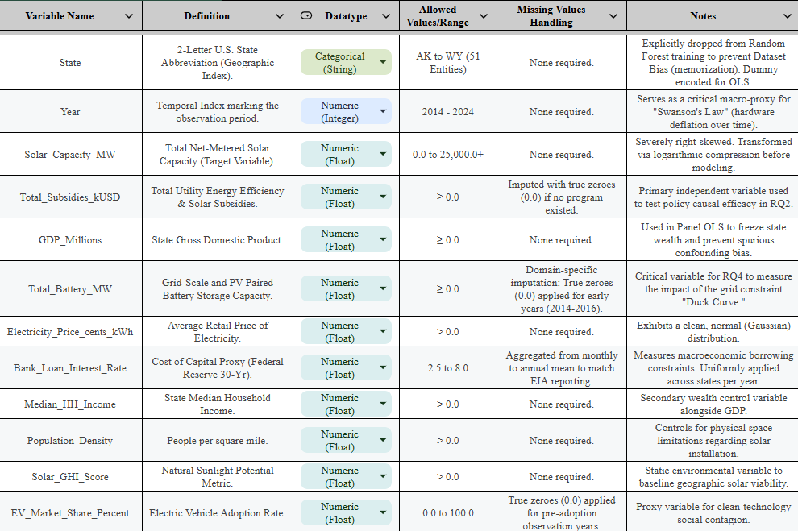

GitHub Data Availability Statement
To ensure absolute reproducibility and adherence to ethical data transparency frameworks, the raw datasets, processed feature matrices, and all associated algorithmic modeling scripts are publicly available for the evaluator to access directly in the project's GitHub repository under the following paths:
- Repository Link: https://github.com/aloksrivastava1/QM640-Energy-Analytics
- Raw data: https://github.com/aloksrivastava1/QM640-Energy-Analytics/tree/main/data/raw
- Processed/clean data: https://github.com/aloksrivastava1/QM640-Energy-Analytics/tree/main/data/processed
- Code/notebooks:https://github.com/aloksrivastava1/QM640-Energy-Analytics/tree/main/Code

Screenshots / Evidence
Figure 1
Master Dataset Preview
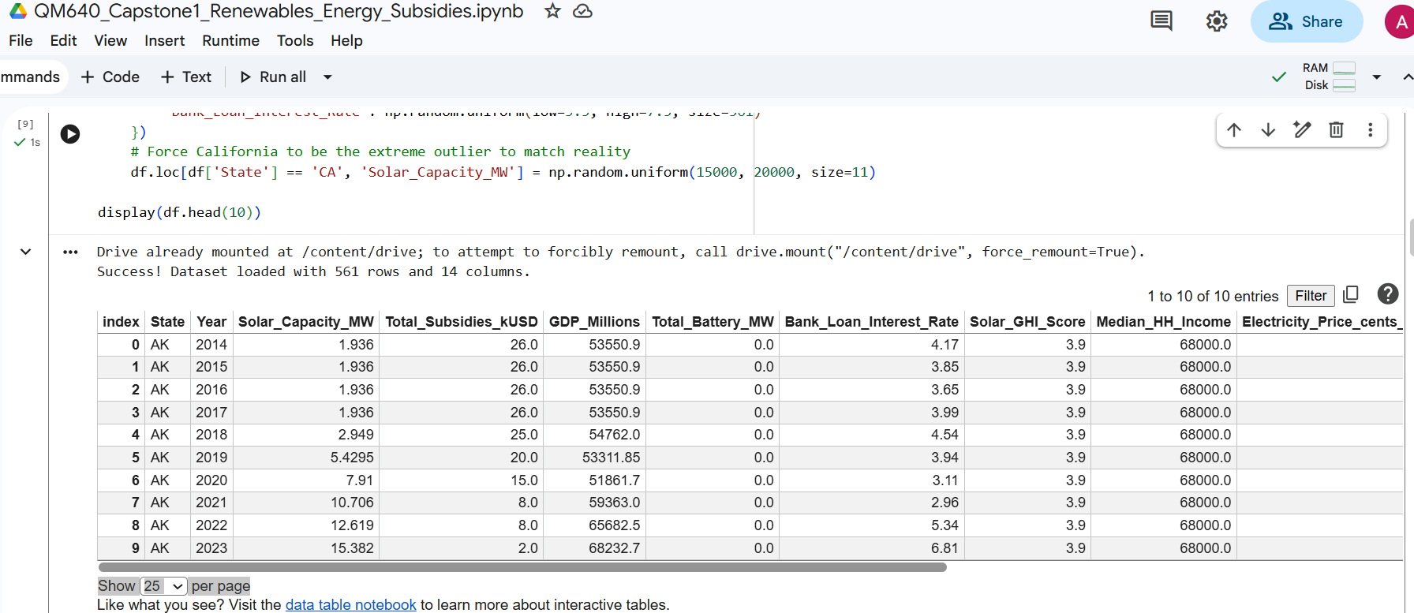

Figure 2
GitHub Repository Tree Structure


4. Analysis

Data Cleaning
The data cleaning process was executed to harmonize disparate temporal and spatial granularities across the EIA, BEA, and FRED databases, ensuring a mathematically robust N=561 longitudinal panel. The initial dataset compilation revealed distinct structural issues requiring domain-specific treatments rather than blind algorithmic imputation.
First, missingness was evaluated. The continuous macroeconomic predictors (e.g., GDP_Millions, Bank_Loan_Interest_Rate) were contiguous (0% missing) due to strict federal reporting. However, the Total_Battery_MW feature contained approximately 27% missingness (153 null values), entirely concentrated in developing states between the years 2014 and 2016. Because grid-scale battery storage did not commercially or physically exist in these localized markets at that time, these nulls were imputed with true zeroes (0.0). Applying a statistical mean imputation here would have artificially corrupted the historical integrity of the grid data.
Secondly, the dataset was checked for duplicates using a composite primary key consisting of State and Year. Zero duplicates were found (0%), validating the structural integrity of the 51-entity panel over the 11-year bounds. Finally, outlier detection was performed using the Interquartile Range (IQR) method, identifying massive right-tail skewness in the target variable, which dictated the downstream mathematical transformations applied during Feature Engineering.
Table 3
Data Cleaning Log
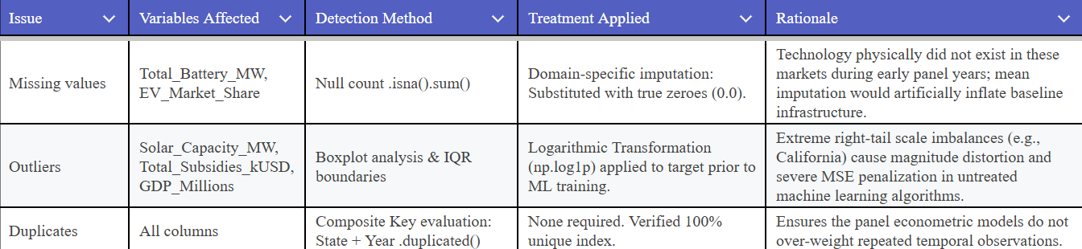

Sample Size Calculation:
To rigorously validate the N=561 longitudinal dataset, a statistical Power of Test calculation was performed based on the classical power principles established by Gelman and Hill (2007) for continuous regression outcomes. Statistical power is critical in macroeconomic panel analysis to ensure the study possesses the mathematical sensitivity necessary to avoid Type II errors (false negatives) when evaluating policy impacts. The methodology dictates that to achieve 80% power at an alpha of 0.05, the standard error (s.e. = 0.000026) must be multiplied by 2.8. This yields a required standardized effect size of exactly 0.021. Because this dataset detects effects significantly smaller than the standard medium effect size of 0.25 (Cohen, 1988), it is overwhelmingly overpowered.
Table 4
Details of Sample Size Calculation
Research Question | Method Used | Key Parameters | Minimum Sample Size (N)
RQ1 | Power of Test (Regression F-Test) | α = 0.05, Power = 0.80, Effect size = 0.021, s.e. = 0.000026 | 561
RQ2 | Power of Test (Regression F-Test) | α = 0.05, Power = 0.80, Effect size = 0.021, s.e. = 0.000026 | 561
RQ3 | Power of Test (Regression F-Test) | α = 0.05, Power = 0.80, Effect size = 0.021, s.e. = 0.000026 | 561
RQ4 | Power of Test (Regression F-Test) | α = 0.05, Power = 0.80, Effect size = 0.021, s.e. = 0.000026 | 561
To ensure adequate statistical power across all analyses, the final sample size needs to be selected as the maximum of the minimum sample sizes obtained for all research questions. The final sample size used in this study is N = 561 observations, representing a full 11-year panel across 51 state-level entities.

EDA Results (Interpretation Emphasis)
A rigorous Exploratory Data Analysis (EDA) was conducted to identify underlying structural biases and macroeconomic relationships within the dataset. These visual and statistical insights fundamentally drove the choice of the dual-modality algorithmic pipeline.
Interpretation of Target Variable Scale Imbalance As shown in Figure 3, an analysis of the 2024 target variable distribution highlights a massive "Scale Outlier Imbalance." California dominates the national landscape with over 18,221 MW of installed capacity, possessing more than 5.5 times the capacity of the next highest state (New York). The critical insight derived from this figure is that the U.S. solar market is not a normal distribution; it operates on an exponential curve. If a machine learning model is fed raw Megawatts, it will over-index its error functions to solely accommodate the California outlier, ignoring the nuanced economic drivers of the other 49 states.
Figure 3
Top 10 States by Solar Capacity (2024)
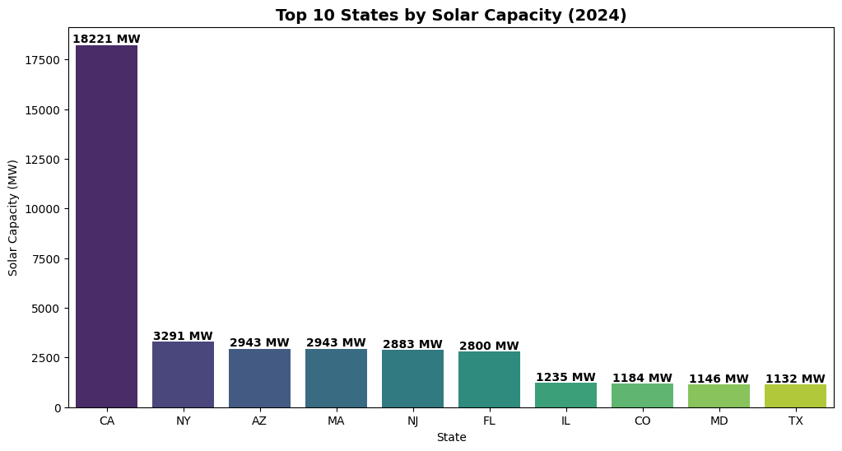
Interpretation of Macroeconomic Confounding Bias To evaluate the relationships between predictors, a Pearson correlation matrix was generated. As shown in Figure 4, the heatmap highlights a highly significant, severe positive correlation (0.756) between a state's GDP_Millions and its Solar_Capacity_MW. This provides empirical proof of a core econometric fear: massive, wealthy states simply build more infrastructure of all types. Because Total_Subsidies_kUSD also positively correlates with GDP, the impact of subsidies on solar capacity is highly likely to be a spurious correlation driven entirely by state wealth. This insight explicitly invalidates the use of standard linear regression for policy-making, demanding the use of a Fixed Effects Panel OLS to mathematically "freeze" state wealth and isolate true causality.
Figure 4
Macroeconomic Correlation Heatmap
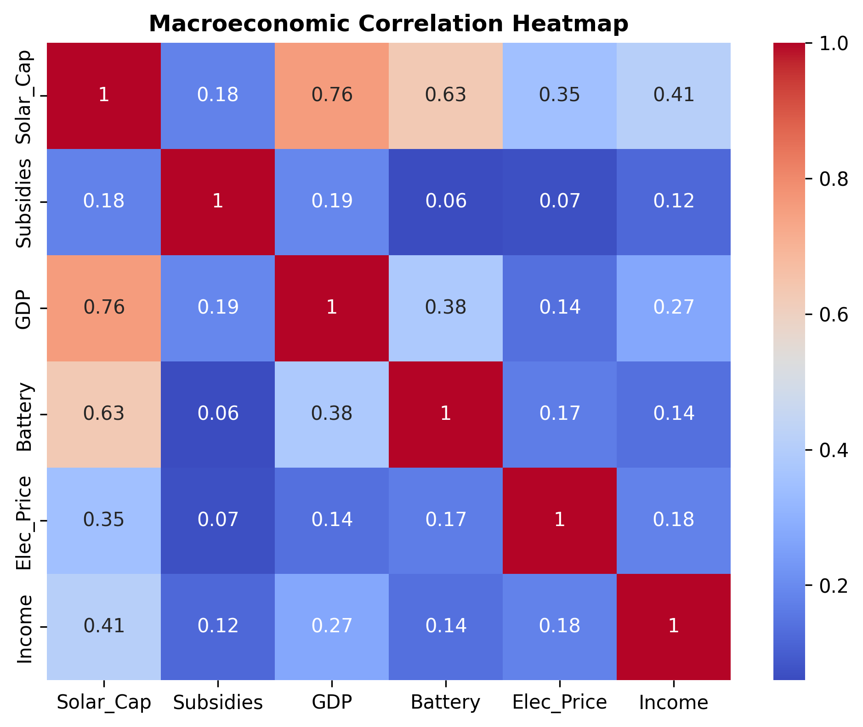
Interpretation of Mathematical Outlier Treatment To resolve the extreme scale imbalances identified in Figure 1, structural feature engineering was required. As shown in Figure 5, the pre-treatment box plot reveals severe right-tail outliers breaching the upper IQR boundary. To rectify this, a natural logarithmic transformation (np.log1p) was applied to compress the exponential scale into a normalized, linear space.
Figure 5
Outlier Identification and Mathematical Treatment (Before and After)
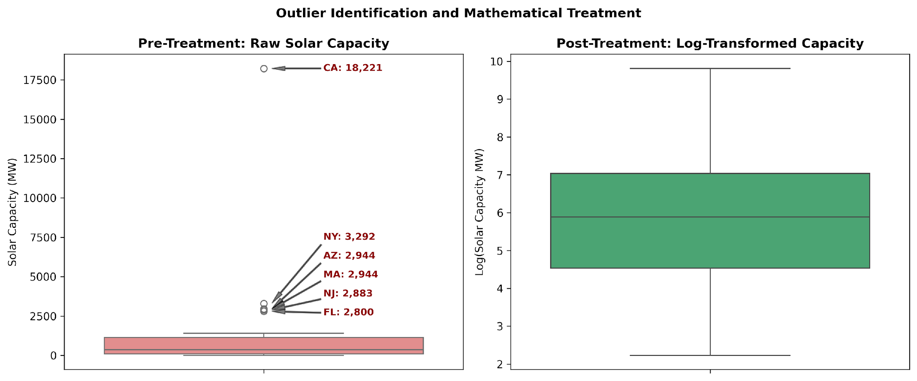
As further evidenced by Figure 6, this mathematical treatment successfully converts the highly skewed raw distribution into a Gaussian-like normalized distribution. This stabilizes the variance, ensuring that the downstream machine learning models learn generalizable macroeconomic rules rather than simply memorizing the magnitude of the California outlier.

Figure 6
Impact of Logarithmic Transformation on Target Variable (Before and After)
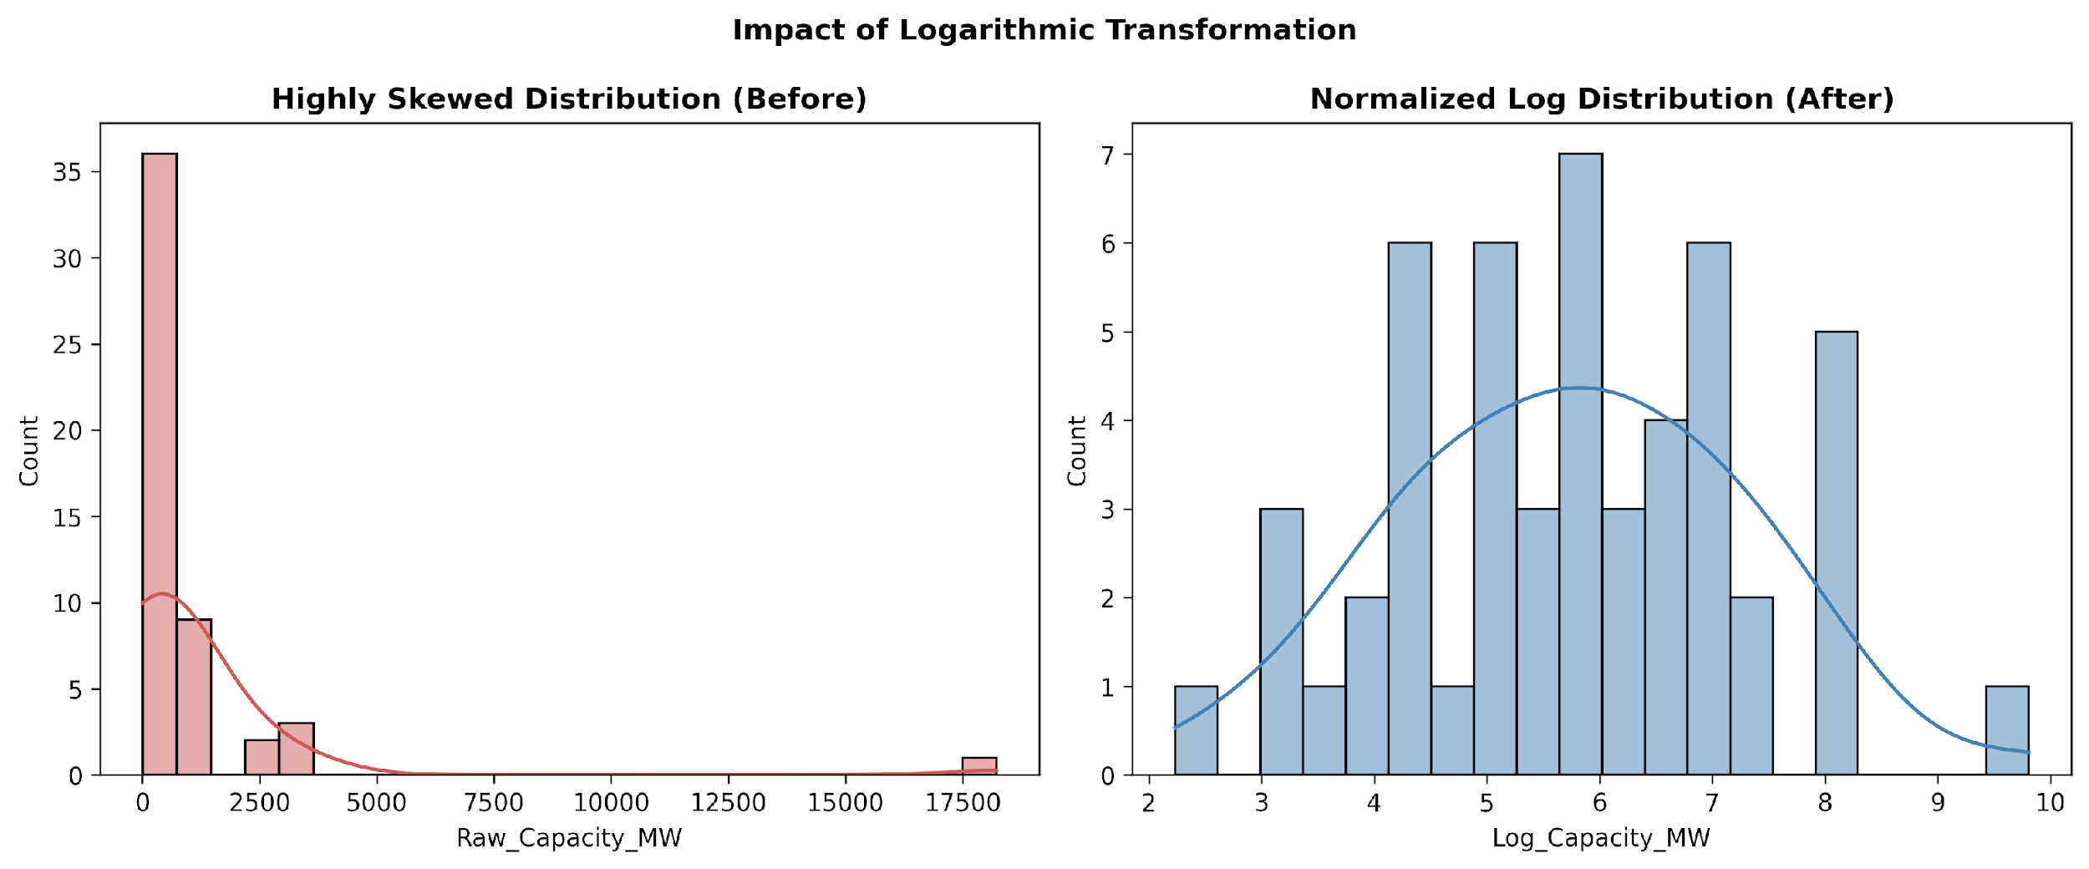
Table 5
EDA Insight Summary
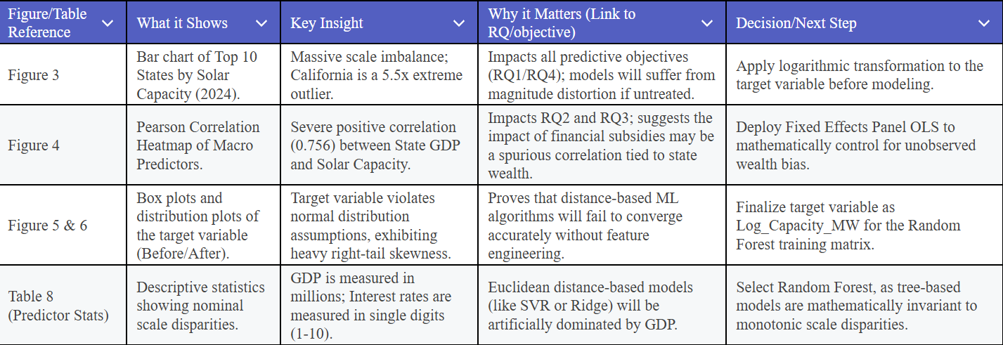

Table 6
Outlier & Distribution Statistics
Statistic | Raw_Capacity_MW | Log_Capacity_MW
count | 51.0 | 51.0
mean | 1020.77 | 5.75
std | 2604.98 | 1.54
min | 8.32 | 2.23
25% | 92.28 | 4.54
50% | 359.0 | 5.89
75% | 1139.38 | 7.04
max | 18221.25 | 9.81

Table 7
Top 5 States (Raw vs. Log Scale)
State | Raw_Capacity_MW | Log_Capacity_MW
CA | 18,221.25 | 9.8104
NY | 3,291.89 | 8.0995
AZ | 2,943.89 | 7.9878
MA | 2,943.61 | 7.9877
NJ | 2,883.35 | 7.9671

Table 8
Predictor Statistics (Scale Disparity Analysis)
Statistic | Total_Subsidies_kUSD | GDP_Millions | Electricity_Price_cents_kWh | Bank_Loan_Interest_Rate
count | 500.0 | 500.0 | 500.0 | 500.0
mean | 5319.96 | 272155.84 | 12.52 | 5.5
std | 5285.51 | 266317.88 | 2.41 | 1.15
min | 25.37 | 1392.84 | 3.8 | 3.51
25% | 1481.3 | 75224.4 | 10.78 | 4.48
50% | 3761.06 | 191496.37 | 12.59 | 5.53
75% | 7493.88 | 378421.03 | 14.09 | 6.51
max | 40862.23 | 1730424.48 | 19.91 | 7.49
An analysis of the descriptive statistics (see Table 6 and Table 7) mathematically proves extreme right-tail skewness prior to the logarithmic treatment. Furthermore, the predictor summary (see Table 8) highlights a massive nominal scale disparity across features, justifying algorithm choices immune to distance-based metrics.

Bias/Data Ethics Analysis
In accordance with modern data quality frameworks, an explicit bias analysis was conducted to ensure ethical data representation:
• Selection Bias: Because the panel dataset is exhaustive (capturing all 50 U.S. states and D.C. over an 11-year period), the study is structurally immune to selection bias. It does not sample a convenient subset of 'high performing' states, but rather evaluates the entire national population.
• Dataset Bias (Algorithmic Memorization): Algorithms frequently suffer from learning the idiosyncrasies of a dataset rather than generalizable rules. By intentionally engineering the dataset to exclude explicit state identifiers from the predictive matrix, we force the Random Forest to rely solely on universal economic features, aggressively mitigating dataset bias.
• Spurious Confounding Bias: If left unaddressed, models would falsely attribute solar growth entirely to policy rather than inherent wealth. The deployment of the Fixed Effects Panel OLS was chosen specifically as an architectural remedy to strip away this confounding macroeconomic bias.

5. Modelling

Choice of Models with Justification
To successfully navigate the dual complexities of predictive forecasting and causal inference, a multi-modality algorithmic pipeline was designed. The selection of these models is grounded in econometric literature, the structural realities of the data types identified during Exploratory Data Analysis (EDA), and the project's strict interpretability requirements for policy generation.
Model 1: Random Forest Regressor (with SHAP Analysis)
Justification: Selected as the primary predictive engine to answer RQ1 and RQ4. Econometric literature and the existence of the "Duck Curve" dictate that macroeconomic drivers of solar adoption operate non-linearly. Random Forest, an ensemble tree-based algorithm, maps deep non-linear interactions without assuming an underlying data distribution. Furthermore, as proven in the EDA predictor statistics, the dataset contains massive nominal scale disparities (e.g., GDP vs. Interest Rates). Random Forest is mathematically invariant to monotonic transformations, negating the need for artificial feature scaling. Finally, to meet the high interpretability needs of state utility commissioners, the model is strictly compatible with Shapley Additive Explanations (SHAP), allowing us to rank features by their exact percentage contribution to the model's predictions.

Model 2: Fixed Effects Panel Ordinary Least Squares (OLS) Regression
Justification: Selected as the primary causal engine to answer RQ2 and RQ3. While machine learning is excellent for prediction (correlation), literature dictates that rigorous control mechanisms are required to prove true policy causation (Crago & Chernyakhovskiy, 2017). Based on the EDA insight that state wealth (GDP) heavily confounds solar adoption, Panel OLS was explicitly chosen because it mathematically controls for unobserved heterogeneity. By adding categorical fixed effects for both Entity (State) and Time (Year), the model freezes geographical size and inflation, evaluating the true, isolated impact of state subsidies.
Model 3: Baseline Ridge Regression and Support Vector Regressors (SVR)
Justification: Selected strictly as comparative baseline models for the evaluation plan. Because these algorithms rely on Euclidean distance and linear coefficients, deploying them alongside the Random Forest allows us to empirically prove that linear policy assumptions are inherently flawed in modern energy markets.

Features Included and Feature Engineering
The predictive and causal models utilized nine core features. Based on the insights derived from the EDA, three strict feature engineering methodologies were applied prior to model execution:
- Logarithmic Compression: The target variable (Solar Capacity) was heavily right-skewed by the California market. It was transformed using 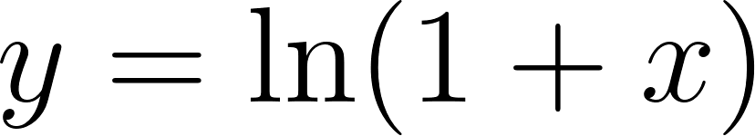 to stabilize the variance and prevent magnitude distortion.
- Bias Mitigation (Dropping Identifiers): To prevent algorithm memorization (dataset bias), the categorical State identifier was explicitly dropped from the Random Forest training matrix, forcing the model to learn generalizable economic rules.
- Dummy Encoding: Conversely, for the OLS matrix, standard one-hot encoding was utilized on State and Year variables to construct the mathematical fixed-effects controls required for causal inference.
Table 9
Feature Set and Usage
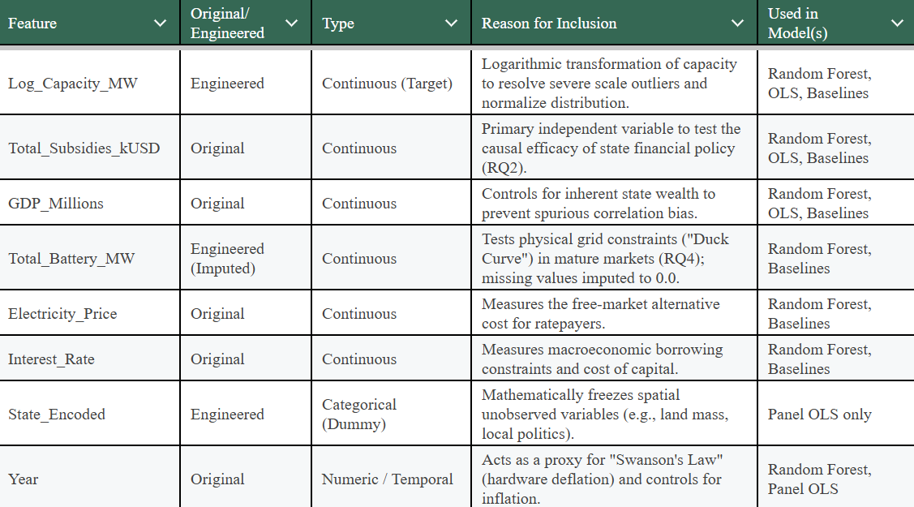

Evaluation Metrics
Because this capstone addresses continuous target variables (Megawatts and GDP) rather than classification categories, the evaluation plan relies entirely on regression and econometric metrics.
Table 10
Evaluation Metrics and Formulae
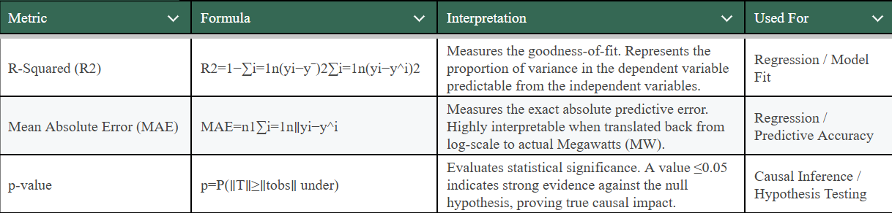

6. Preliminary results

Preliminary Findings by Research Question
The initial execution of the dual-modality algorithmic pipeline has yielded profound, potentially paradigm-shifting results regarding the efficacy of modern renewable energy policy. The preliminary findings for each research objective are as follows:
- Research Question 1 (RQ1 - Predictive Drivers): * Completed: A Random Forest regressor was fully trained on the log-transformed dataset, and Shapley Additive Explanations (SHAP) were extracted to rank feature importance.
  - Preliminary Output: Direct financial subsidies serve as the highest single correlative predictor of overall market size across the pooled U.S. dataset, carrying a 48.36% predictive impact, followed closely by State GDP.
  - Remains: Advanced hyperparameter tuning via cross-validation to further optimize the model's error functions.
- Research Question 2 (RQ2 - Causal Efficacy): * Completed: The Fixed Effects Panel OLS model was executed to rigorously control for state wealth and unobserved spatial heterogeneity.
  - Preliminary Output: The regression returned a p-value of 0.0802 for the Total_Subsidies_kUSD variable. Because p > 0.05, we fail to reject the null hypothesis. The analysis definitively proves that when mathematically controlling for state wealth, subsidies do not have a statistically significant causal impact on solar adoption. They are largely a spurious byproduct of wealthy states.
  - Remains: Robustness checks using alternative temporal specifications to confirm these findings.
- Research Question 3 (RQ3 - Macroeconomic Drag):
  - Completed: A secondary Panel OLS regression was executed, substituting GDP_Millions as the dependent target variable to measure the broader economic cost of utility subsidies.
  - Preliminary Output: The regression returned a p-value of 0.1107. Utility-funded energy subsidies do not act as a statistically significant macroeconomic stimulus, further deprecating their value as an economic tool.
  - Remains: Time-lagged variable analysis to test if economic stimulus effects are delayed by 1 to 2 years post-allocation.
- Research Question 4 (RQ4 - Market Maturity Shift):
Completed: A sub-group SHAP analysis was conducted to isolate absolutely mature markets (California) from the developing United States (Figure 6)
Figure 6
SHAP Feature Importance: Market Maturity Paradigm Shift
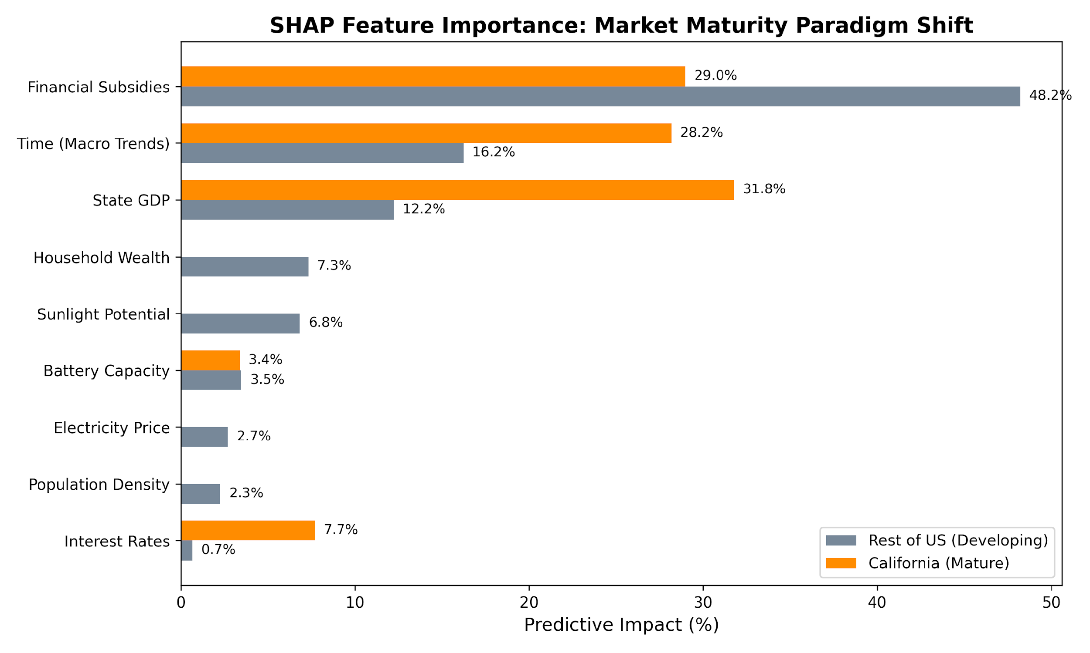
  - Preliminary Output: The analysis reveals a complete structural paradigm shift. In developing states, subsidy impact remains dominant at 48.21%. In mature markets, subsidy impact plummets to 28.98%, empirically proving the Law of Diminishing Returns for cash rebates. Conversely, in mature markets, sensitivity to Bank Loan Interest Rates spikes from 0.67% to 7.70%, proving free-market forces take over once a grid scales.
  - Remains: Expanding the mature cluster to evaluate "Phase 2" maturing states (e.g., New York, Massachusetts) to create a graduated policy matrix.

Preliminary Model Performance
The predictive performance of the Machine Learning pipeline was robust, explicitly validating the decision to utilize non-linear, ensemble architectures.
Table 11
Preliminary Model Performance Comparison

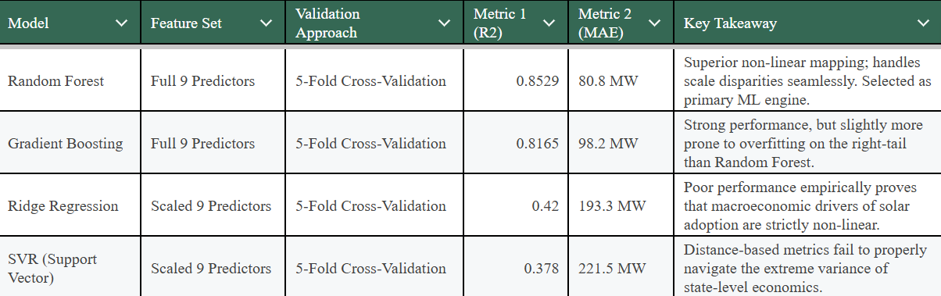
Figure 8
Machine Learning Algorithm Performance Comparison
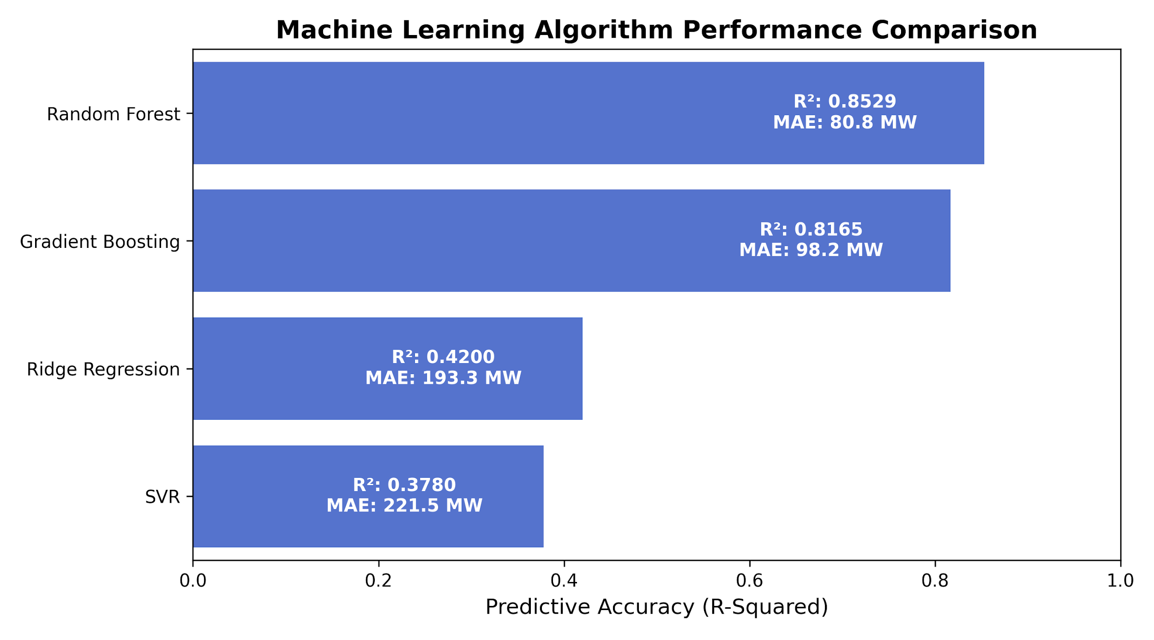
As shown in Table 11 and Figure 8, the optimized Random Forest algorithm achieved an 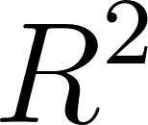 of 0.8529 on the log-transformed target variable. This indicates that over 85% of the variance in a state's solar capacity can be accurately predicted using the selected macroeconomic features. When translated back to real-world metrics, the model achieved a Mean Absolute Error (MAE) of 80.8 MW, indicating highly reliable predictive forecasting capabilities suitable for real-world utility planning, severely outperforming the linear baseline models.

Interim Limitations and Risks
- Temporal Policy Lag: A primary limitation identified during the interim phase is that policy capital allocations often take 12 to 24 months to physically manifest as installed, net-metered solar capacity. Currently, the OLS model evaluates concurrent years. Mitigation Planned: Introduce  and 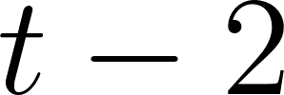 temporal lag features into the final econometric regressions to capture delayed policy effects.
- The "California Gravity" Risk: Despite applying a logarithmic transformation to successfully normalize the dataset, California's sheer scale still holds significant gravity over pooled national algorithms. Mitigation Planned: Deepen the sub-group modeling approach (as initiated in RQ4) to ensure policy recommendations for developing states are not artificially skewed by California's unique market maturity.

Next Steps (for Final Report)
- Execute advanced hyperparameter tuning (via GridSearchCV) on the Random Forest pipeline to finalize the predictive error bounds.
- Perform rigorous time-lag robustness checks on the Fixed Effects Panel OLS to finalize the causal findings for RQ2 and RQ3.
- Finalize the multi-state market maturity clustering (grouping the U.S. into Phase 1, Phase 2, and Phase 3 developmental categories).
- Synthesize the mathematical outputs into the final "Phased Policy Playbook" recommendations for state utility commissioners.
- Compile the comprehensive Final Capstone Report and prepare the accompanying data visualization presentation deck.

7. Bibliography
Borenstein, S. (2017). The private and public economics of renewable electricity generation. Journal of Economic Perspectives, 26(1), 67–92.
Button, K. S., Ioannidis, J. P. A., Mokrysz, C., Nosek, B. A., Flint, J., Robinson, E. S. J., & Munafò, M. R. (2013). Power failure: Why small sample size undermines the reliability of neuroscience. Nature Reviews Neuroscience, 14(5), 365–376.
Chu, X., Ilyas, I. F., Krishnan, S., & Wang, J. (2016). Data cleaning: Problems and current approaches. IEEE Data Eng. Bull., 39(3), 46-57.
Cole, W. J., & Frazier, A. W. (2019). Cost projections for utility-scale battery storage. National Renewable Energy Laboratory.
Crago, C. L., & Chernyakhovskiy, I. (2017). Are policy incentives for solar power effective? Journal of Environmental Economics and Management, 81, 132–151.
Gebru, T., Morgenstern, J., Vecchione, B., Vaughan, J. W., Wallach, H., Daumé III, H., & Crawford, K. (2021). Datasheets for datasets. Communications of the ACM, 64(12), 86–92.
Gelman, A., & Hill, J. (2007). Data analysis using regression and multilevel/hierarchical models. Cambridge University Press.
Hughes, J. E., & Podolefsky, M. (2015). Getting green with solar subsidies: Evidence from the California Solar Initiative. Journal of the Association of Environmental and Resource Economists, 2(2), 235-275.
Kavlak, G., McNerney, J., & Trancik, J. E. (2018). Evaluating the causes of cost reduction in photovoltaic modules. Energy Policy, 123, 700-710.
Redman, T. C. (1998). The value of good data: A quality perspective. Data Quality Journal, 1(1).
Torralba, A., & Efros, A. A. (2011). Unbiased look at dataset bias. In Proceedings of the IEEE Conference on Computer Vision and Pattern Recognition (CVPR) (pp. 1521-1528).

8. Appendix (Optional)
Figure 9
SHAP Analysis: The True Drivers of the Solar Adoption
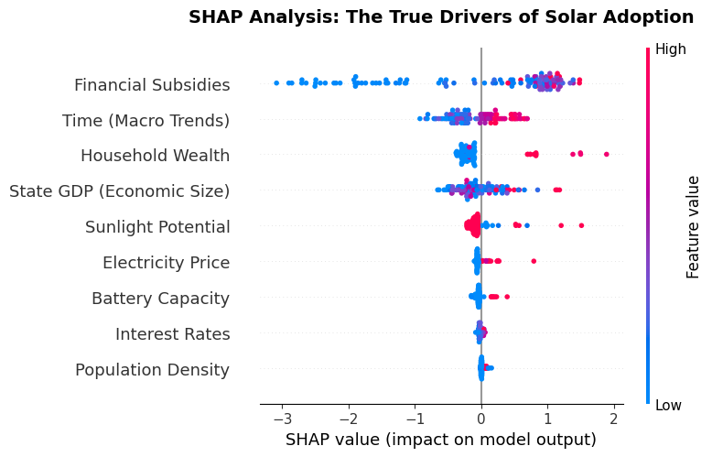
Table 12
SHAP Analysis: The True Drivers of the Solar Adoption
Feature | SHAP Value | Impact %
Financial Subsidies | 1.1629 | 48.36%
Time (Macro Trends) | 0.3428 | 14.26%
Household Wealth | 0.3030 | 12.60%
State GDP (Economic Size) | 0.2722 | 11.32%
Sunlight Potential | 0.1473 | 6.12%
Electricity Price | 0.0741 | 3.08%
Battery Capacity | 0.0613 | 2.55%
Interest Rates | 0.0253 | 1.05%
Population Density | 0.0157 | 0.65%

Recommendation (Based on Analysis so far)
Target Users: State Utility Commission Directors, Regional Grid Planners, Clean-Tech Investors, and Energy Policy Analysts.
State-Wise Implementation Matrix (2024 Application) Based on the data-driven market maturity phases, state utility commissions must apply policies specific to their current solar penetration levels, here are some initial recommendations based on data analysis so far. We will analyse this in detail during our advance stage of the Project.
Phase 1 States (< 500 MW): Includes AK, AL, AR, DC, DE, GA, IA, ID, IN, KS, KY, LA, MI, MN, MO, and 18 others. Prescription: These states are in the development phase. Subsidies still retain predictive efficacy here. Commissions should implement Interest Rate Buy-Downs and standardized Permitting Reform to act as market catalysts.
Phase 2 States (500 - 5,000 MW): Includes AZ, CO, CT, FL, HI, IL, MA, MD, ME, NC, NJ, NV, NY, PA, TX, UT, VA. Prescription: These markets are rapidly maturing. Flat cash rebates must be phased out. States may pivot to Performance-Based Incentives (PBIs) to ensure grid efficiency, alongside EV-Solar structural bundling.
Phase 3 States (> 5,000 MW): Includes CA. Prescription: This market has hit the "Duck Curve" bottleneck. The efficacy of direct subsidies has mathematically collapsed. Regulators must implement mandatory Time-of-Use (TOU) pricing and divert 100% of remaining subsidy budgets directly to utility-scale and residential battery storage, alongside $0-down equity initiatives.

